

IBM RPA Dashboards

Hands-on Lab

*Version 1.0*

*Public*

*Authors:*

*Nigel T. Crowther – ncrowther@uk.ibm.com*

**Table of Contents**

1. Introduction 3

Prerequisites 3

2. Scenario 1 – Basic Report 4

3. Scenario 2 – Bot status report 10

# Introduction

This hands-on lab you will learn how to create a custom dashboard in your RPA tenant.

Dashboards enable you to monitor running and completed bots. You can create sophisticated dashboards like the one below:

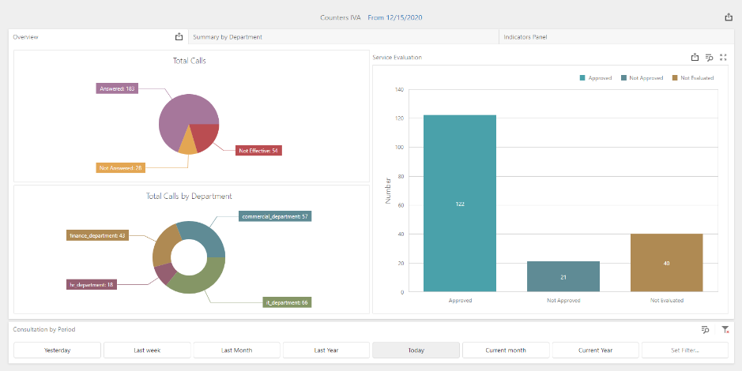

The dashboard reads data from three data sources

* Jobs
* Counters
* Workflows and Processes

You can have a dashboard for every bot or a dashboard for a business area such as sales, marketing and finance. Each Dashboard can display multiple indicators.

## Prerequisites

Nothing. Your environment is already configured, and everything is set. Ready to start.

# Scenario 1 – Basic Report

Login to your tenant and click *Dashboards*:

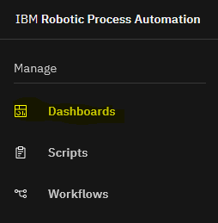

Click on New Dashboard and then click *Edit in Designer.* See below:

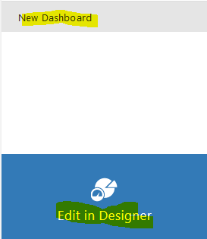

Click on Main dashboard menu icon:

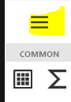

Click New…

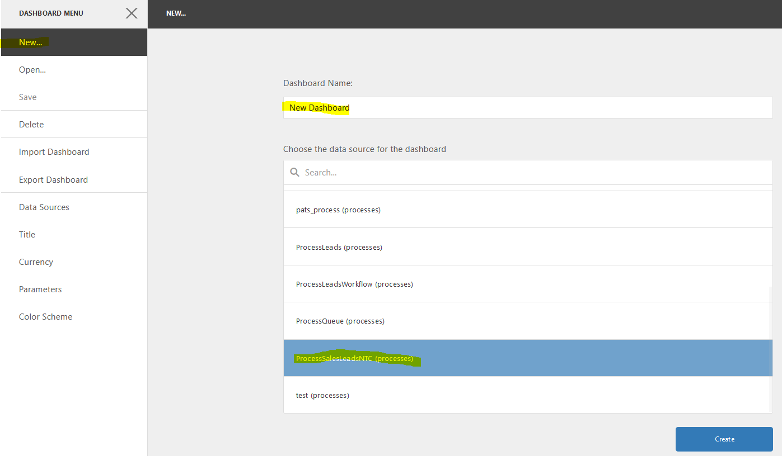

Set the name of the dashboard to *Bot Status* and the data source to Default, and then press *Create*.

Click the Pie icon:

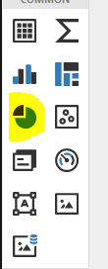

Click on the Click here link:

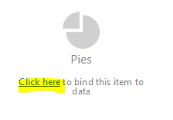

Select *Process Instance Id* as the Value. See below:

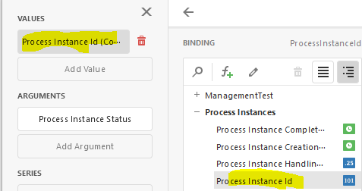

Select *Process Instance Status* as the argument. See below:

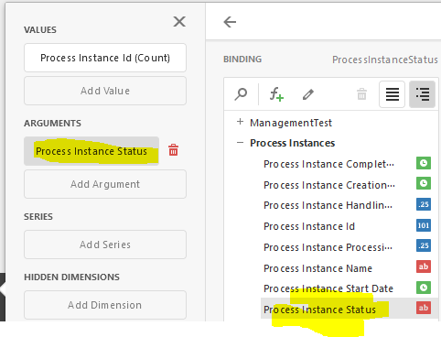

A pie chart showing the selected data is shown:

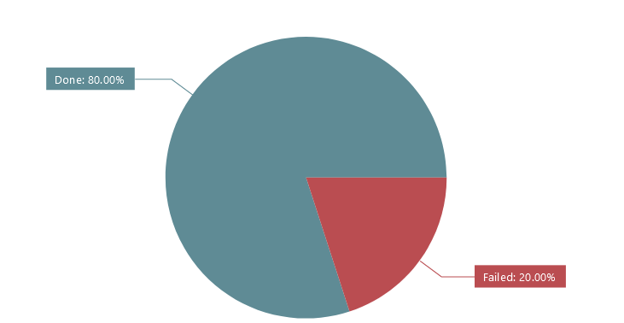

Click *Viewer* and *Save*.

Your simple status dashboard is now created. Click on Viewer:



Now press save. The new dashboard can now be viewed by other users of the tenant.

In view mode, click the  icon. This will give you three options to export the dashboard. Choose Pdf:

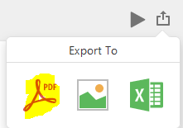

Select the default options:

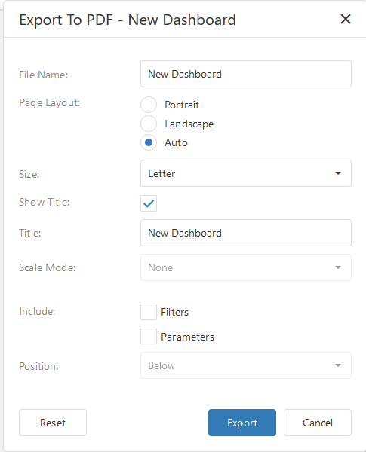

Press Export. Set the *Save File* option and press *OK*.

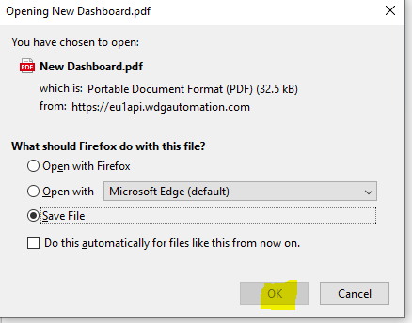

The pdf is saved to your local drive.

# Scenario 2 – Bot status report